**Project Documentation**

**Designing Infographics Using Canva**

1. **Introduction**

1.1 **Overview**

- Briefly describe the purpose and scope of the project.

- Explain why infographics are essential in conveying information effectively.

1.2 **Purpose**

- State the primary objectives of the project.

- Mention the importance of using Canva as the design tool.

2.Problem Definition & Design Thinking

2.1 Empathy map

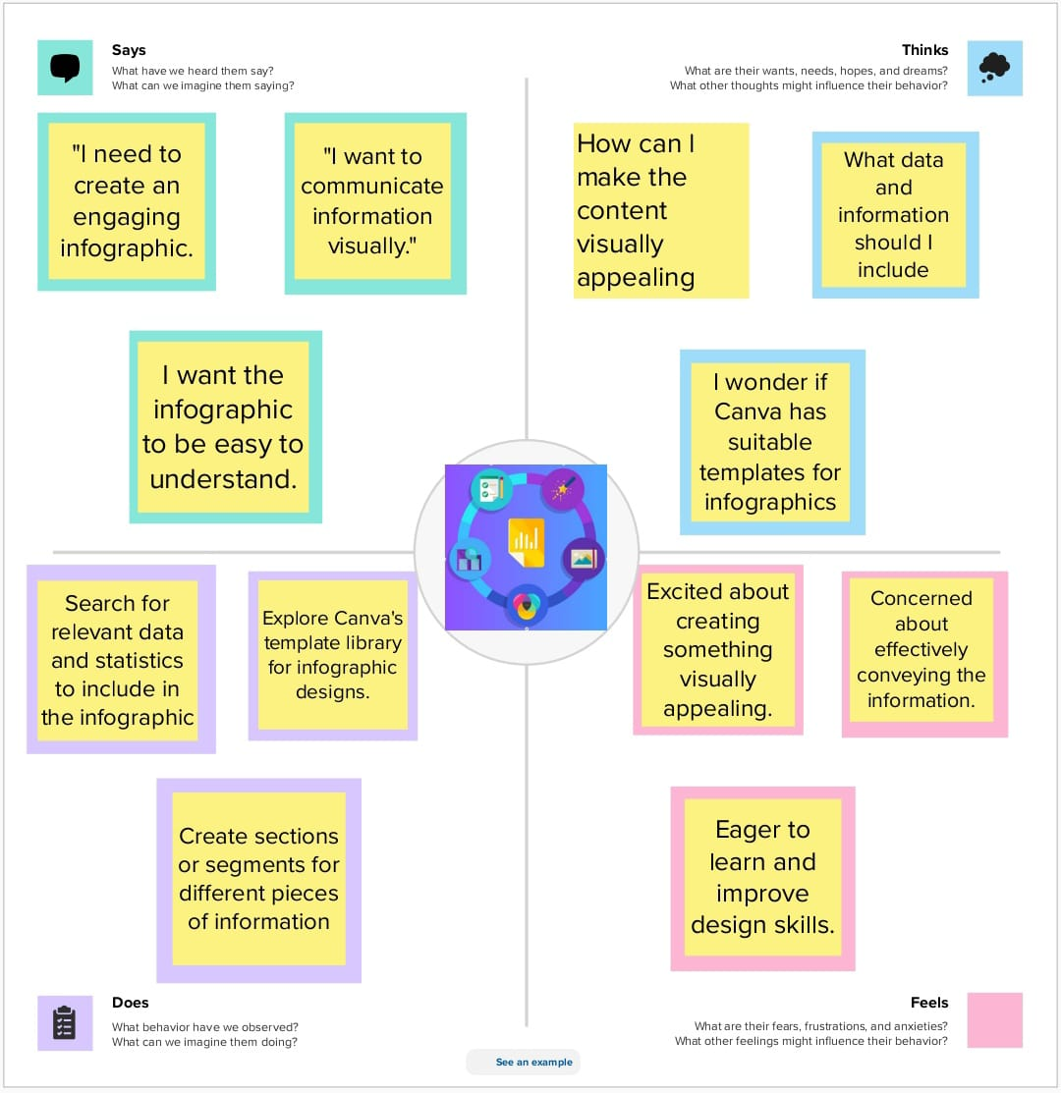

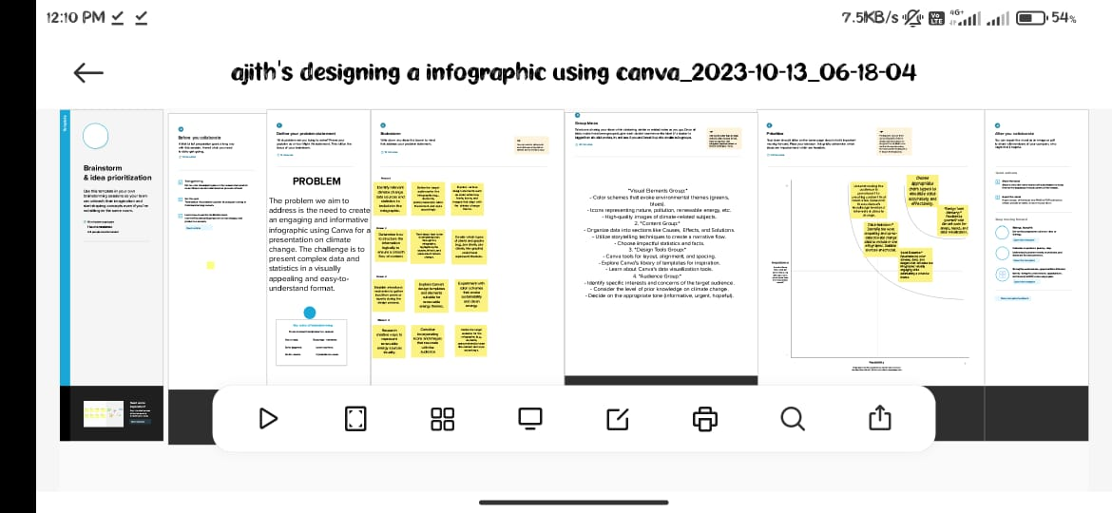

Result:

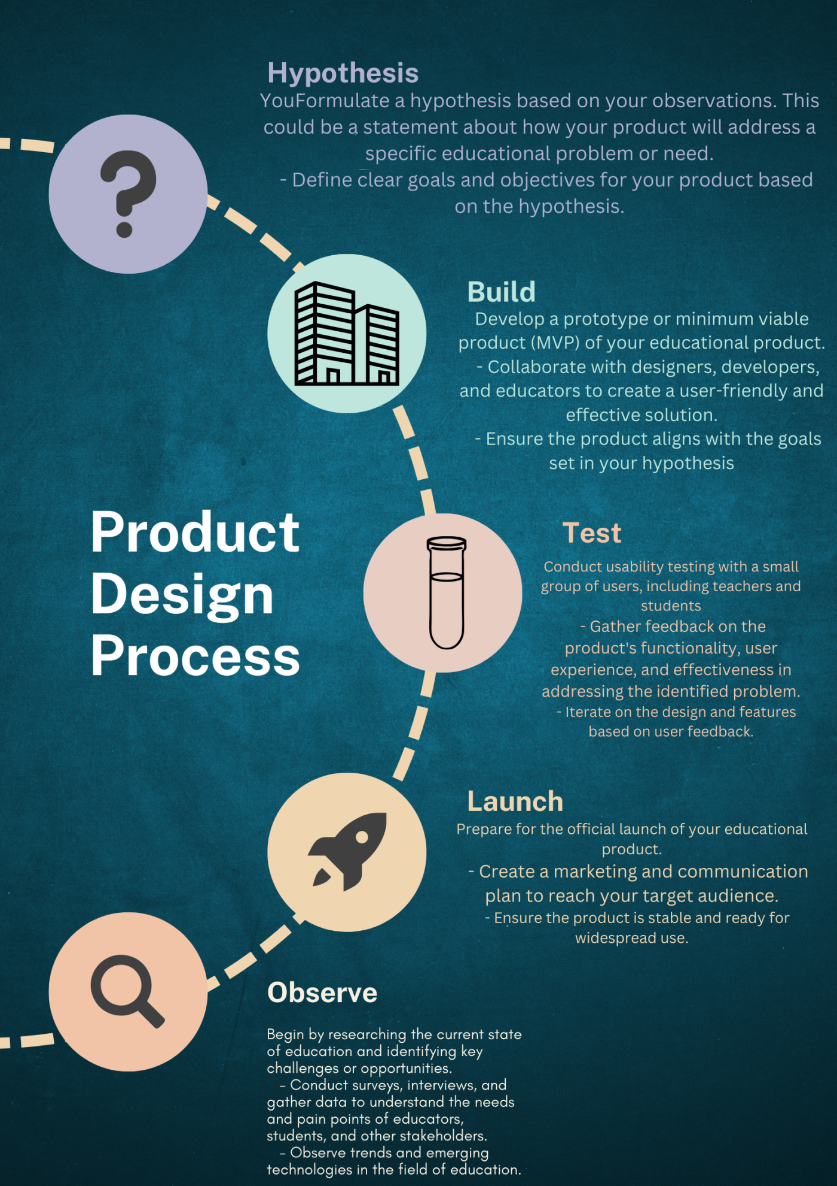

4. **Advantage & Disadvantage**

**2.1 Advantages of Designing Infographics Using Canva**

- List and explain the benefits of using Canva for infographic design.

- Provide real-life examples of successful infographics created with Canva.

**2.2 Disadvantages of Designing Infographics Using Canva**

- Highlight any limitations or challenges that users might face.

- Offer potential solutions or workarounds to address these disadvantages.

**3. Conclusion**

- Summarize the key findings and insights from the project.

- Emphasize the value of using Canva for infographic design.

**4. Future Scope**

- Discuss potential areas for future research or improvements in the field of infographic design.

- Consider emerging technologies or design trends that might impact infographic creation.

**5. Appendix**

- Include additional resources and references used in the project.

- Attach sample infographics designed with Canva.

- Provide any supplementary materials that enhance the understanding of the project.